Response to BTRC Requirement (Part-1)

**Practical Experience in Integrated Platform Development**

**Requirement:** Bidder shall have at least 2 (two) practical experiences in developing monitoring/analytics/SAS/OSS/BSS/QoS platforms or integrated service management platforms with integration to at least 3 external systems (e.g. NMS, billing, CRM, ERP).

# Project 1: Common Interconnection SMS Platform (CISP)

|  |  |
| --- | --- |
| Client | Association of ICX Operators Bangladesh (AIOB) |
| Status | Live in Production |
| Duration | Ongoing since 2022 |

## Project Overview

Telcobright designed, developed, and operates the Common Interconnection SMS Platform (CISP) — the national SMS transit gateway that routes all inter-operator SMS traffic in Bangladesh. This mission-critical platform serves as the centralized softswitch for SMS interconnection among all Mobile Network Operators (Grameenphone, Robi, Banglalink, Teletalk) and 12+ IPTSP operators.

We humbly note that platforms of this complexity and national significance are typically delivered by global telecom vendors such as Ericsson, Huawei, and Nokia. Telcobright's successful delivery demonstrates our capability to execute carrier-grade, nationally critical infrastructure projects.

## Scope & Technical Achievement

|  |  |
| --- | --- |
| **Aspect** | **Description** |
| Architecture | DC-DR redundant deployment across 2 geographically distributed POPs with automatic failover |
| Availability | 99.999% uptime SLA — satisfying the stringent requirements of Tier-1 MNOs |
| Traffic Volume | Processes millions of SMS messages daily across all Bangladesh operators |
| Protocol Complexity | SIGTRAN/SS7 signaling with complex MSU correlation across distributed nodes |
| CDR Generation | Real-time correlation of multi-leg signaling transactions to generate accurate billing records |
| Billing System | Complete billing platform with reconciliation accuracy matching MNO expectations |

## External System Integrations (Exceeds 3+ Requirement)

|  |  |  |
| --- | --- | --- |
| **#** | **Integration Type** | **Systems Integrated** |
| 1 | SIGTRAN Protocol Integration | 5 MNOs (GP, Robi, Banglalink, Teletalk) + 12+ IPTSPs |
| 2 | NMS/OSS Integration | Real-time statistics collection, system health monitoring |
| 3 | Automated Alerting System | Stakeholder notifications for link failures, transmission issues |
| 4 | Billing/Settlement System | CDR generation and inter-operator settlement reconciliation |
| 5 | Network Infrastructure | BGP routing, IPSec overlay networks, secure interconnection |

# Detailed Technical Project Design & Requirement Documents

This section contains detailed technical documentation, architecture diagrams, and screenshots demonstrating the platform capabilities and integrations.

# Relevance to BTRC QoS Monitoring Project

|  |  |
| --- | --- |
| **CISP Experience** | **BTRC Project Application** |
| Handling MNO first-class citizen data (SMS) | Handling ISP operational data (secondary, less sensitive) |
| 99.999% availability for national infrastructure | High availability for regulatory monitoring platform |
| Real-time signaling correlation & CDR generation | Real-time QoS metric computation & reporting |
| Multi-operator integration (17+ entities) | Multi-ISP integration (1,500+ entities) |
| NMS/OSS integration with automated alerting | Dashboard integration with automated compliance alerts |
| Carrier-grade billing reconciliation | Revenue analytics and ARPU computation |

## Conclusion

If Telcobright can satisfy the exacting standards of Bangladesh's major MNOs with their mission-critical SMS traffic, we are well-positioned to deliver a robust QoS monitoring platform for BTRC that handles secondary operational data from ISPs.

Live URL and supporting documents available upon request.

# NMS/OSS Integration Screenshots

The following screenshots demonstrate the Network Management System (NMS) developed by Telcobright for CISP infrastructure monitoring. This system provides real-time visibility into network health, BGP routing, and alerting across multiple sites (Borak Tower, Khaja Tower, Khulna, Dhaka).

## 1. Storage Health Monitoring

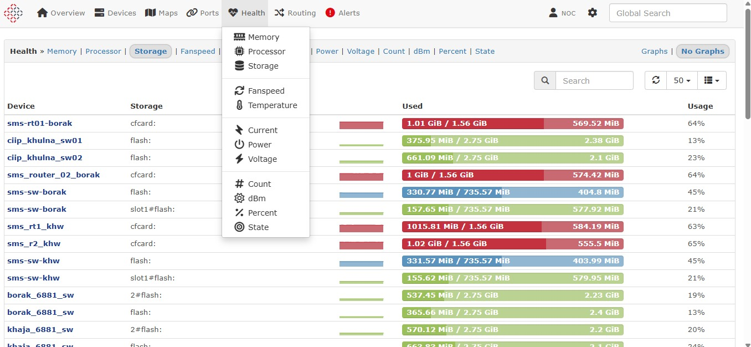

*Figure 1: NMS Health Dashboard - Storage utilization monitoring for SMS platform devices across Borak, Khulna, and Khaja sites. Shows real-time storage usage with visual indicators for capacity planning.*

## 2. Memory Health Monitoring

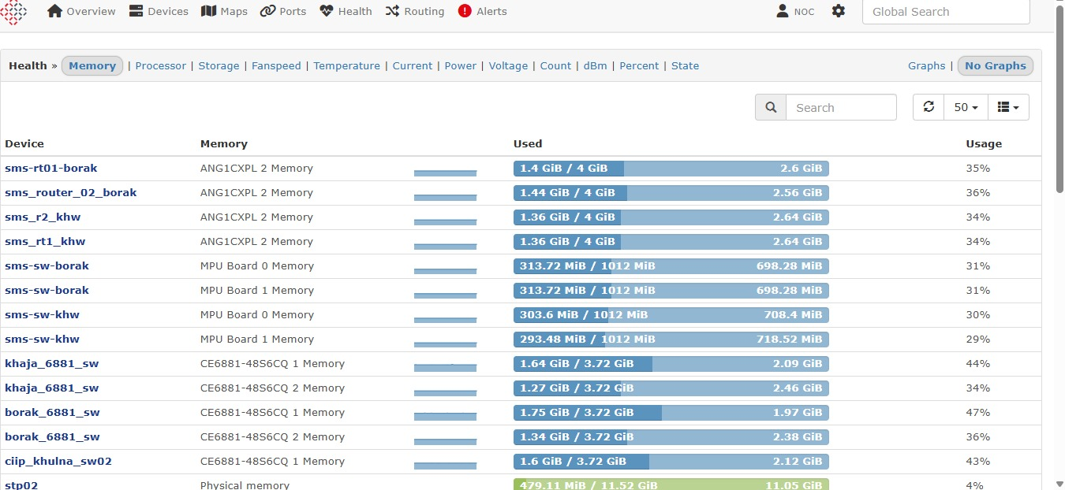

*Figure 2: NMS Health Dashboard - Memory utilization monitoring for network devices including routers (ANG1CXPL), switches (CE6881-48S6CQ), and STP nodes. Displays used/total memory with percentage indicators.*

## 3. BGP Routing Session Monitoring

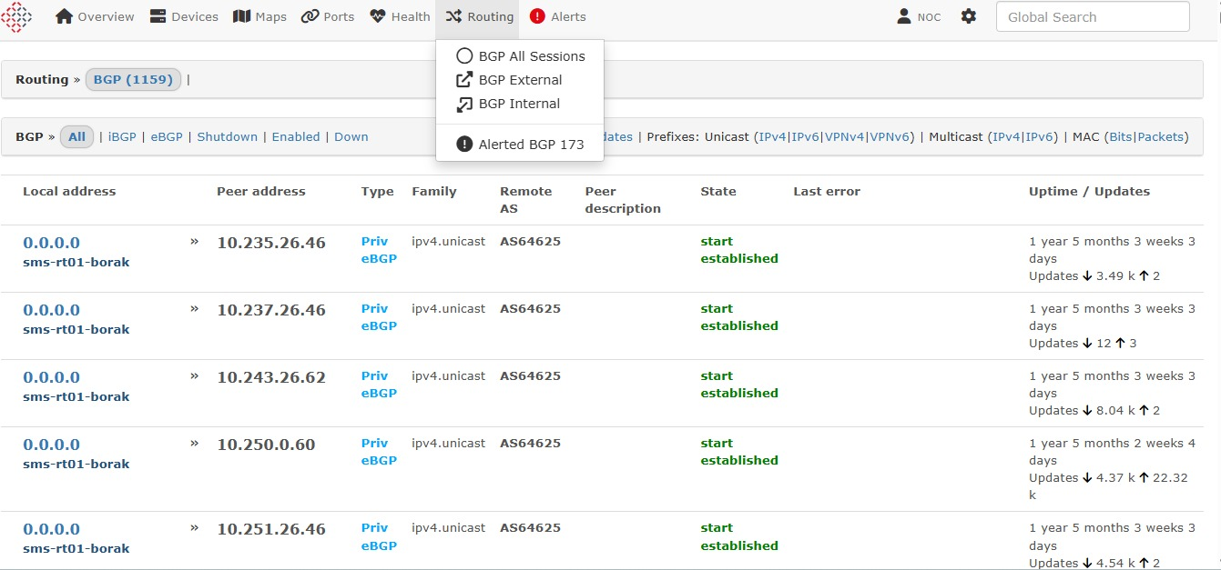

*Figure 3: NMS Routing Dashboard - BGP session monitoring showing 1,159 active BGP sessions. Displays eBGP peers with AS numbers, session state (established), uptime (1+ years), and route update statistics. Supports filtering by iBGP, eBGP, IPv4, IPv6, VPNv4, VPNv6.*

## 4. Device Alerts Timeline

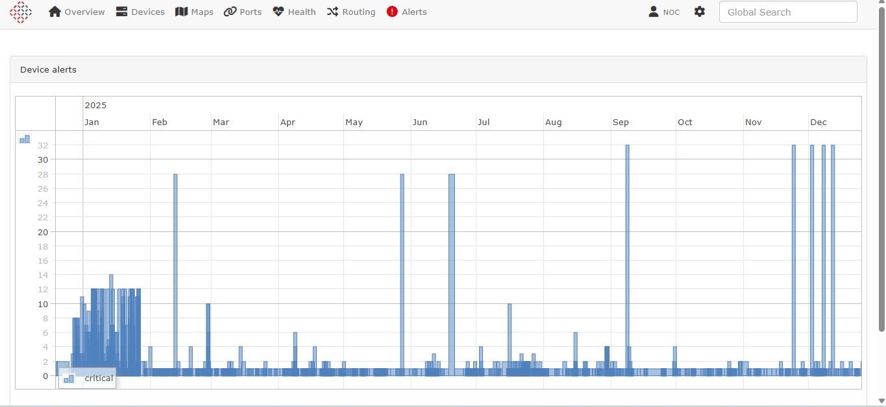

*Figure 4: NMS Alerts Dashboard - Annual device alerts timeline for 2025 showing critical alert distribution. Enables trend analysis for infrastructure stability and proactive maintenance planning.*

## 5. Alert Log Entries

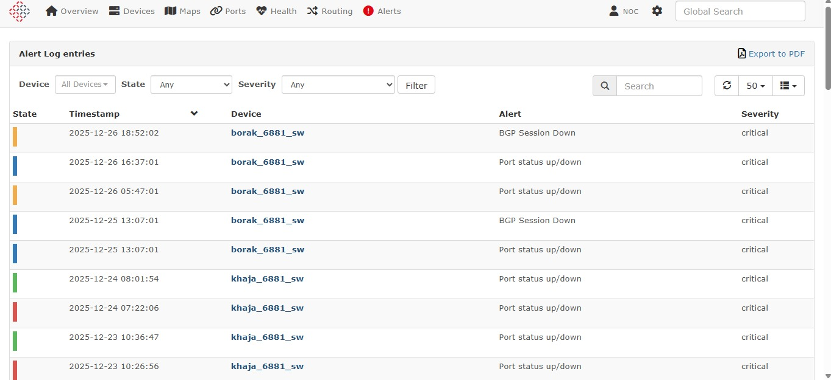

*Figure 5: Alert Log showing recent critical alerts including BGP Session Down and Port status up/down events for Borak and Khaja site switches. Provides timestamped event tracking with severity classification.*

## 6. Geo-Located Alert Management

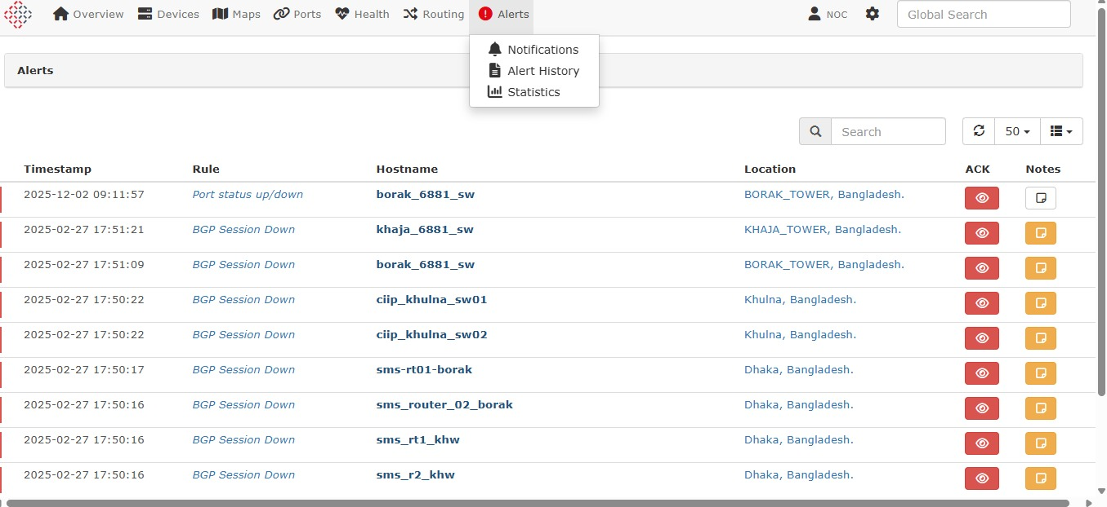

*Figure 6: NMS Alerts with geographic location tracking - Shows BGP Session Down alerts mapped to physical locations (BORAK_TOWER, KHAJA_TOWER, Khulna, Dhaka). Includes acknowledgement (ACK) and notes functionality for NOC operations.*

## 7. Alert Notification System

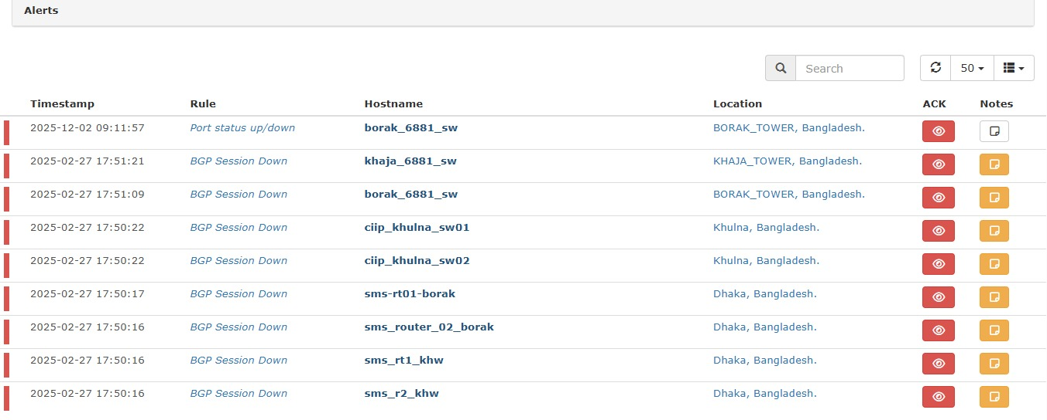

*Figure 7: Alert notification and history view showing BGP Session Down events across multiple devices with location-based grouping. Supports export to PDF, filtering, and integration with ticketing systems.*

## NMS Key Features Demonstrated

* • Multi-site monitoring: Borak Tower, Khaja Tower, Khulna, Dhaka
* • Health monitoring: Memory, Storage, Processor, Temperature, Fanspeed, Power, Voltage
* • BGP routing: 1,159+ sessions with IPv4/IPv6/VPNv4/VPNv6 support
* • Real-time alerting: BGP Session Down, Port status, with severity levels
* • Geographic tracking: Location-based alert management
* • NOC integration: Acknowledgement, notes, PDF export capabilities

# Appendix: Full Design doc of the CISP project

**AIOB Signaling Requirements and Final Topology**

